**Chef Knife Commands**

Following are some of the commonly used Chef Knife commands.

* To create a new cookbook



Note: use underscore instead of “-” (hyphen) in cookbook names. Hypen seem to prevent identification of LWRPs included in the cookbook.

* To upload a new or modified cookbook



* To list all the nodes currently defined in Chef



* To show details about a node



Note: -l option generates a detailed list of properties about the node. Leaving it out will generate a summary about the node. Use -a option to query about a particular node attribute

* To edit a new node or modifying an existing node



This will let you edit the node details using the default editor set

* To add a node defined in a file to Chef



* To list all the roles defined in Chef



* To show details about a role



Use -a option to query about a particular role attribute value

* To add a role from a file



* To edit a new or existing role



* To add a role or recipe to a node

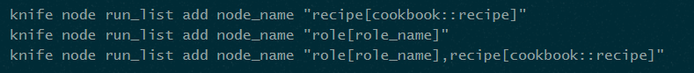

* To remove role or recipe from a node use “remove” instead of “add”



* To bootstrap a new node with Chef

